**HOMEWORK: Bar & Column Charts**

In the **Data_Viz_Homework** file, click on the "Bar & Column Charts" tab and complete the following:

**1)** Create a **Clustered Column** chart to show *Citizen Population*, *Registered Voters* and *Confirmed Voters* by state, for the Top 10 states by population. Adjust formatting to match the chart below:

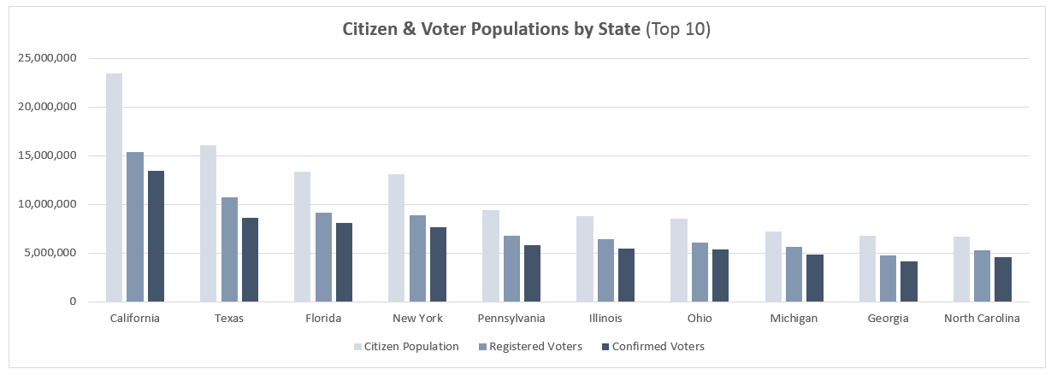

**2)** Create **Bar Charts** to show *Citizen Population* and *Confirmed Voters* for the same 10 states, and adjust formatting to match the examples below:

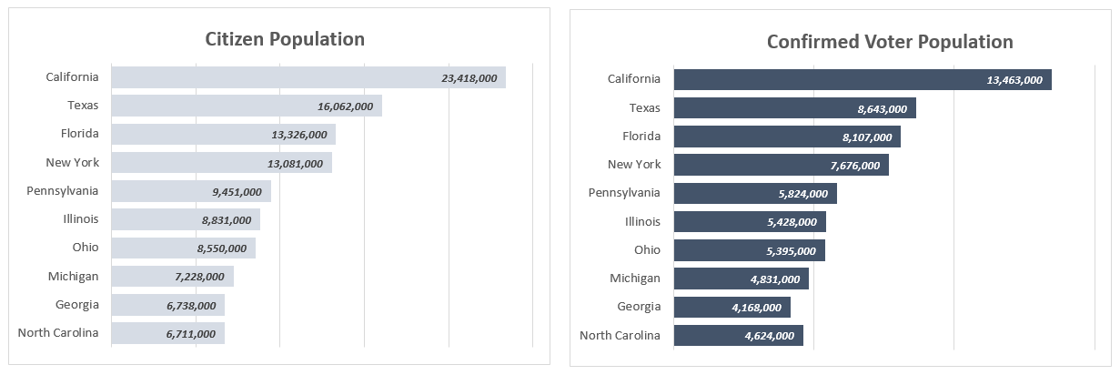

**HOMEWORK: Histogram & Pareto Charts**

In the **Data_Viz_Homework file**, click on the "Histogram & Pareto Charts" tab and complete the following:

**1)** Create a **Histogram** to show the distribution of *Total Pay (k)*, with a fixed bin width of **$10k**. Which bin represents the largest portion of the sample?

**2)** Copy and paste the chart, and change the chart type to a **Pareto Chart**. Adjust formatting to match the examples below:

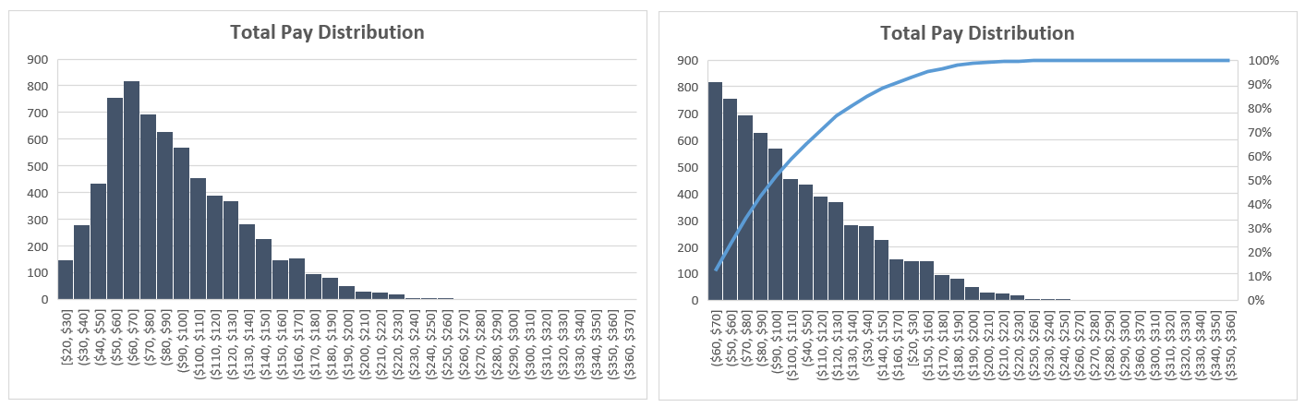

**HOMEWORK: Line Charts & Trendlines**

In the **Data_Viz_Homework** file, click on the "Line Charts" tab and complete the following:

**1)** Insert a **Line Chart** to show *Mean Temp (F)* by day for the entire data sample, and add a **Polynomial Trendline** (Order = 2). How does the mean temperature change over the course of the year?

**2)** Create a second **Line Chart** to show *Mean Wind Speed (MPH)* by day for the entire data sample, and add a **Polynomial Trendline** (Order = 2). How does the mean wind speed change over the course of the year?

**3)** Adjust formatting to match both charts below:

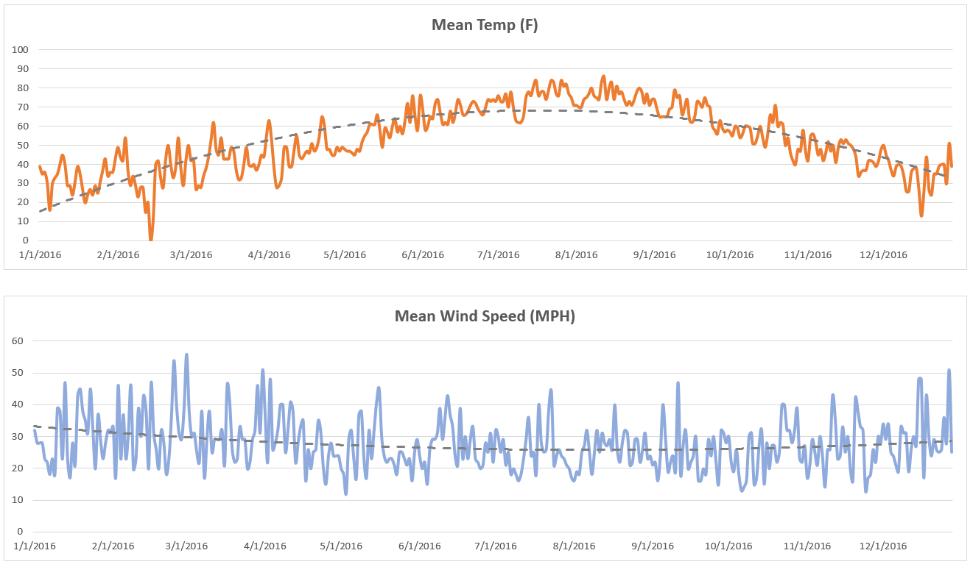

**HOMEWORK: Area Charts**

In the **Data_Viz_Homework** file, click on the "Area Charts" tab and complete the following:

**1)** Rearrange data in columns A-C to show *Gross Revenue* by Year (as columns), with one row for each *Rating* (G, PG, PG-13 & R)

**2)** Using your restructured data, insert a **Stacked Area Chart** to show *Gross Revenue* trending by year, by *Rating*. Update the chart style to match the chart below (**hint:** it's a standard option):

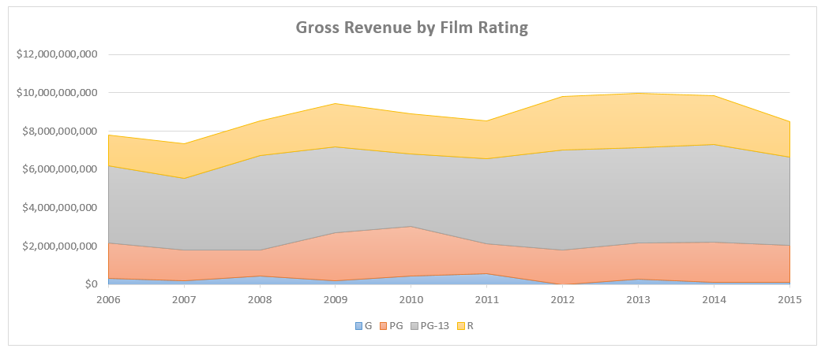

**HOMEWORK: Pies, Donuts & Race Tracks**

In the **Data_Viz_Homework** file, click on the "Pie & Donut Charts" tab and complete the following:

**1)** Create **Pie Charts** to show the *# of Posts* and *Post Engagements* by time of day (Morning, Afternoon, Evening & Late Night)

**2)** Create **Donut Charts** to show the *# of Posts* and *Post Engagements* by post type (Photo, Video, Link & Event)

**3)** Adjust formatting to match the Pie and Donut charts below:

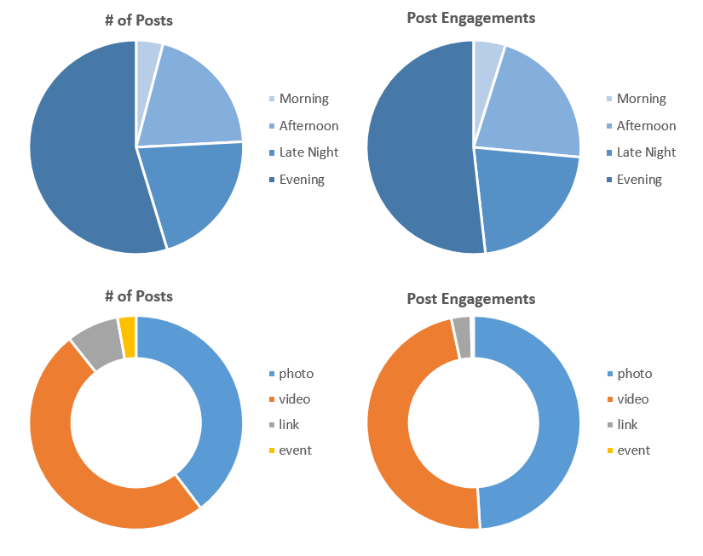

**BONUS:** Calculate the number of **total** post engagements (across all post types or times of day), and create source data to make a gauge chart showing progress towards a total engagement goal of **500,000**. Adjust formatting to match the example below:

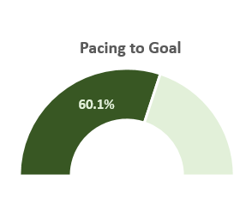

**HOMEWORK: Scatter Plots & Bubble Charts**

In the **Data_Viz_Homework** file, click on the "Scatter Plots & Bubble Charts" tab and complete the following:

**1)** Create a **Scatter Plot** showing *Salary* on the X-axis and *Wins* on the Y-axis, and add a **Logarithmic Trendline** with the R-squared value displayed on the chart.

**2)** Duplicate the chart and adjust to show *Homeruns* on the X-axis instead of *Salary*. Which metric is more highly correlated with Wins; *Salary* or *Homeruns*? (**Hint:** The higher the R-squared values, the higher the correlation)

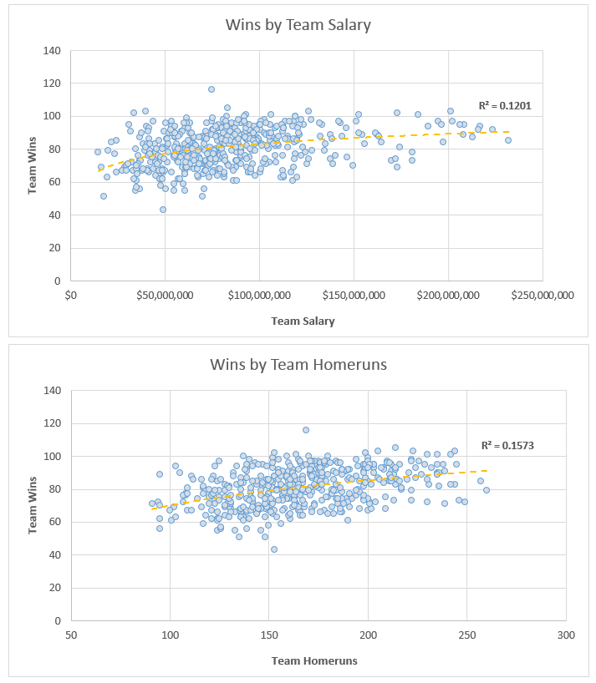

**3)** Convert your chart from #2 above to a **Bubble Chart**, update your data ranges to include **2015** only, and make the size of the bubbles a function of *Salary*. Scale the bubble size to **40**, set the transparency to **50%**, and add data labels to show the *TeamID* inside of each bubble:

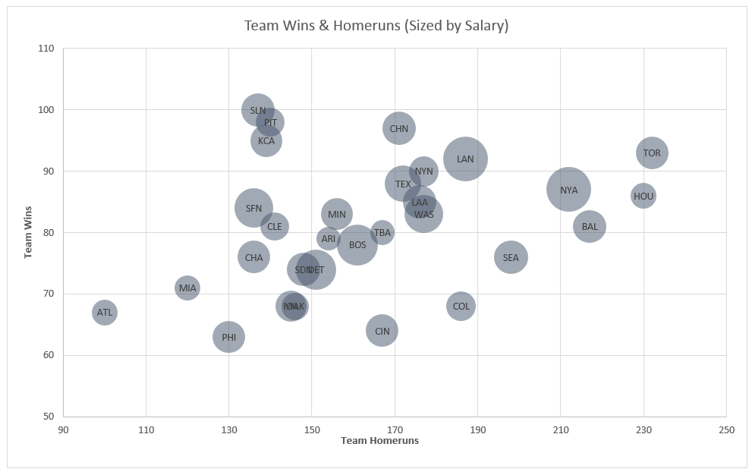

**HOMEWORK: Box & Whisker Charts**

In the **Data_Viz_Homework** file, click on the "Box & Whisker Charts" tab and complete the following:

**1)** Insert a **Box & Whisker** chart based on the data in columns B and C to show *Gross Revenue* comparisons across Genres. Your chart should look like the following example:

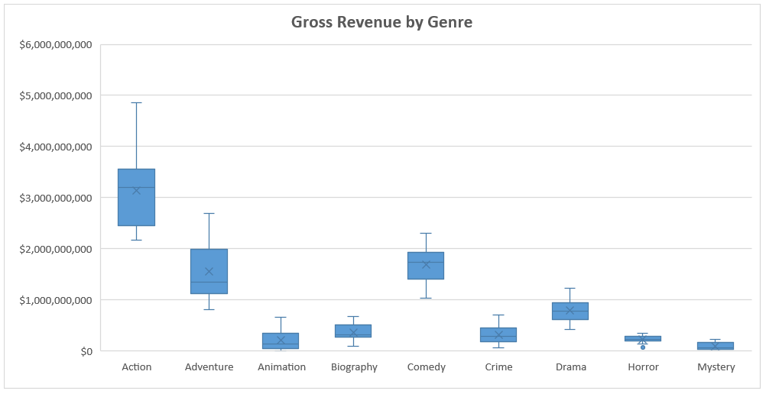

**2)** Do you see any outliers in the chart? Which genre has the second-highest mean value for *Gross Revenue*?

(*Answers below... No cheating!*)

**\*** There is one outlier, noted by a round dot on the chart: Gross Revenue for Horror films in 2002 ($64,933,022). Comedy films have the second highest mean value for Gross Revenue.

**HOMEWORK: Tree Maps & Sunburst Charts**

In the **Data_Viz_Homework** file, click on the "Tree Maps & Sunburst Charts" tab and complete the following:

**1)** Using the Product data in columns A-C, create a **Tree Map** to show the distribution of orders by *Product Category* and *Product Sub-Category*. Duplicate the chart and change to a **Sunburst**, then adjust formatting (if necessary) to match the examples below:

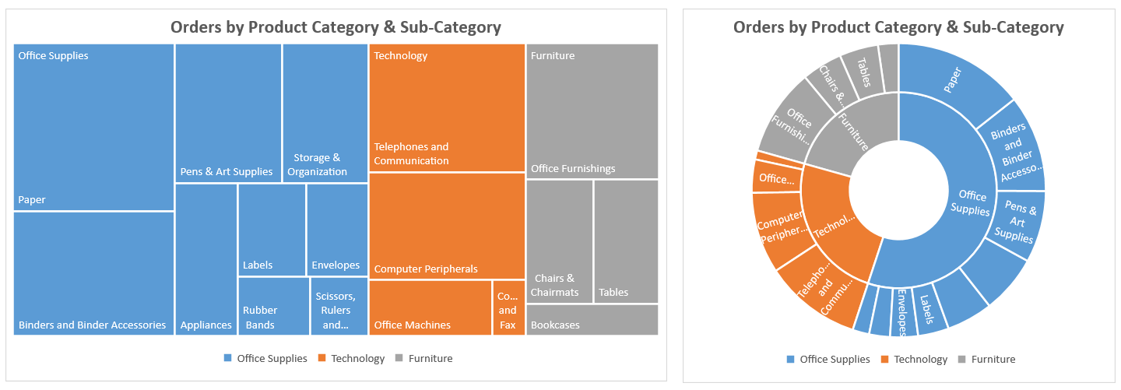

**2)** Create the raw source data (from scratch) to produce the **Sunburst** chart below (bonus points if you can match the formatting exactly):

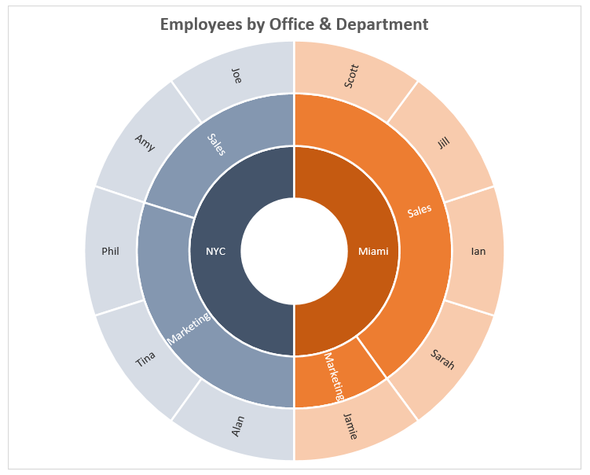

**HOMEWORK: Waterfall & Funnel Charts**

In the **Data_Viz_Homework** file, click on the "Waterfall & Funnel Charts" tab and complete the following:

**1)** Insert a **Waterfall Chart** based on the financial data in columns A-B, and set *Gross Revenue*, *Gross Profit*, *Operating Income* and *Net Income* as totals:

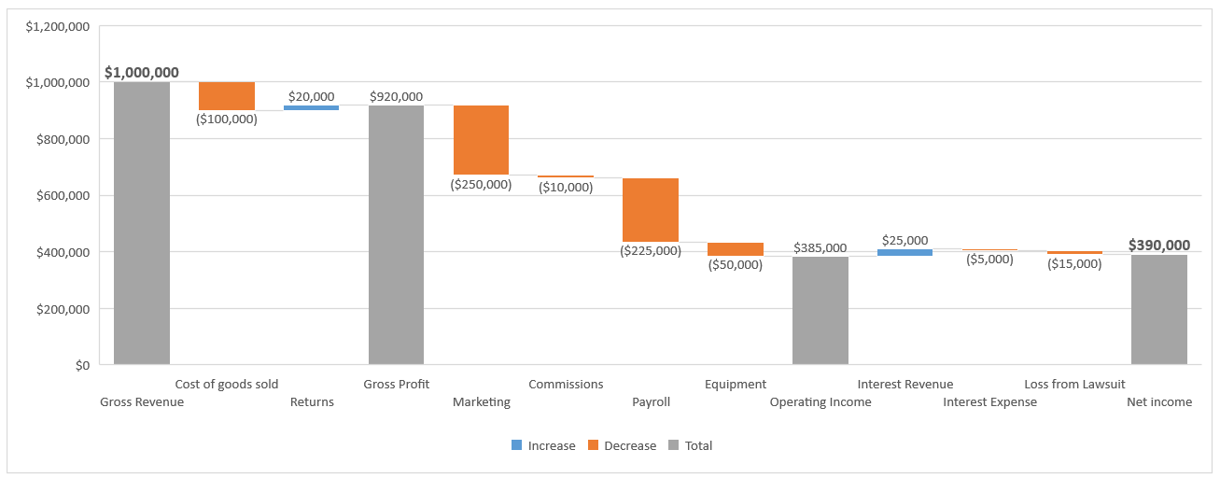

**2)** You just posted a job opening, and a total of **100** people applied. Of the **100** applicants, you invited **45** to interview. **15** declined, but among those who interviewed **50%** were invited to a second round. **5** people from round two were invited to a final interview, and only **1** was eventually offered the job.

Create a **Funnel Chart** to visualize the number of people who progressed through each of the stages above (initial applicants, first interview, second interview, final interview, etc). You should end up with something like this:

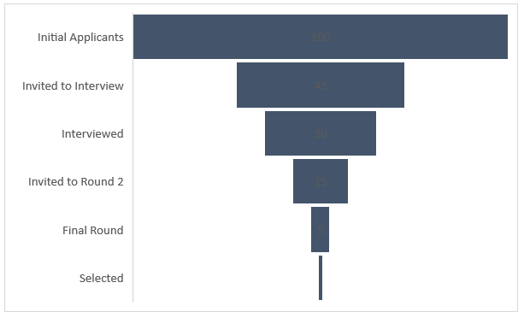

**HOMEWORK: Radar Charts**

In the **Data_Viz_Homework** file, click on the "Radar Charts" tab and complete the following:

**1)** Insert a **Radar Chart** to visualize the number of shark attacks occurring each month in Australia, South Africa, and the USA.

**BONUS:** Create a second source data range to convert the numbers into a **1-100** scale. What do you notice about when shark attacks occur in the USA compared to Australia or South Africa?

**Hint:** Use the following formula to create the new 1-100 scale:

NEW_VALUE = NEW_MIN + (OLD_VALUE - OLD_MIN) * (NEW_MAX - 1) / (OLD_MAX - OLD_MIN)

Your chart should end up looking like this:

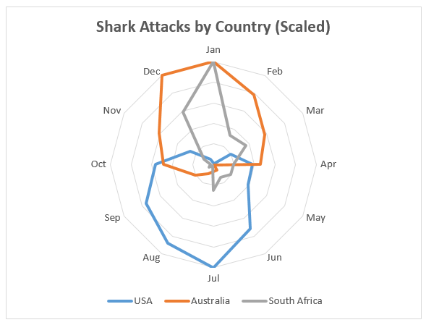

**HOMEWORK: Stock Charts**

In the **Data_Viz_Homework** file, click on the "Stock Charts" tab and complete the following:

**1)** Select all of the Google stock price data in columns B-G and insert a **Stock Chart** (Volume-Open-High-Low-Close).

**2)** Select only columns D-G and insert a second **Stock Chart** (Open-High-Low-Close)

**3)** Adjust the X-axis and secondary Y-axis to match the format below (**hint:** you may need to change your X-axis type):

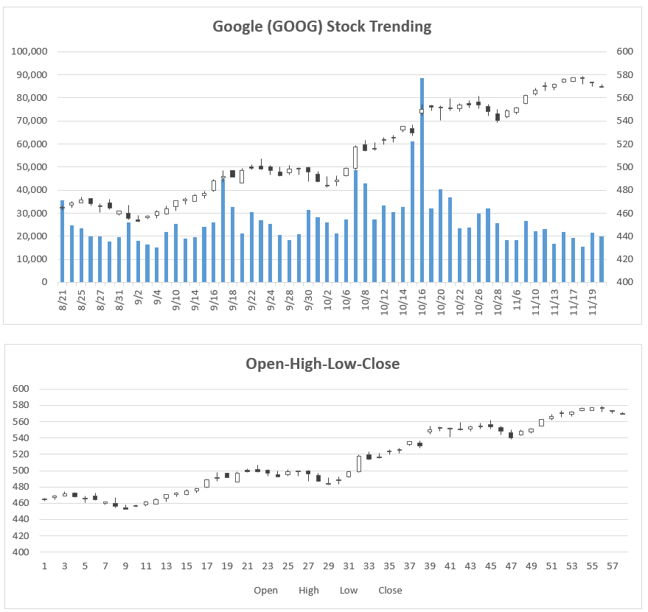

**HOMEWORK: Heat Maps**

In the **Data_Viz_Homework** file, click on the "Heat Maps" tab and complete the following:

**1)** Apply a Red-White-Blue **Color Scale** to column B to show cooler temperatures in blue and hotter temperatures in red. When do temperatures start warming up, and when do they cool back down?

**2)** Apply a Green-White **Color Scale** to column C to show days with no/little precipitation in white and days with a lot of precipitation in green. Which weeks had the highest precipitation totals?

**BONUS:** Apply a custom number format (;;;) to hide the text and only show the color scales. Your final heatmap should look like this:

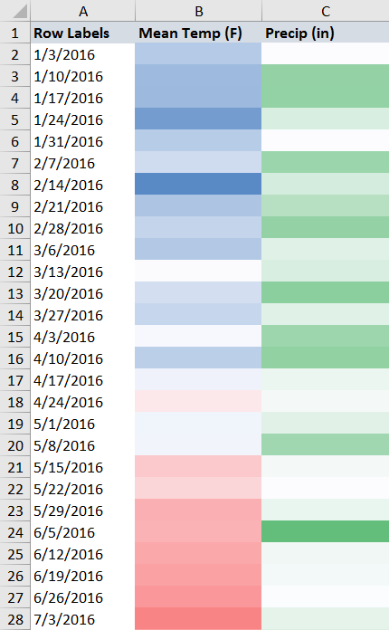

**HOMEWORK: Surface & Contour Charts**

In the **Data_Viz_Homework** file, click on the "Surface Charts" tab and complete the following:

**1)** Insert a **3-D Surface Chart** to visualize the average temperature data in columns A-M. Adjust the color formatting for each band to match the example below, where cooler temperatures are shown in blue/green and warmer temperatures are shown in yellow/orange/red (**hint:** bands can be formatted by clicking on each item in the legend):

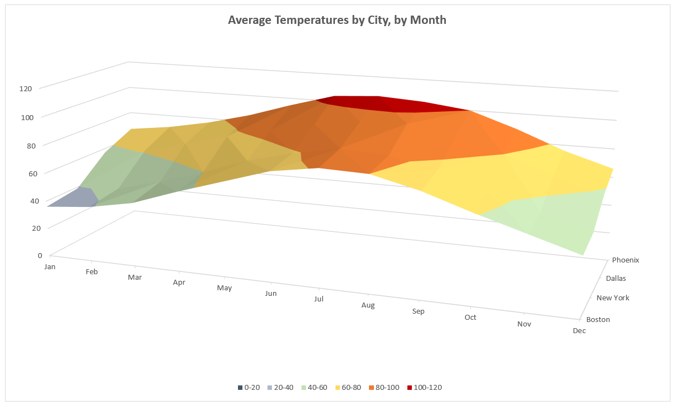

**2)** Create a duplicate and change the chart type to a **Contour Chart** (formatting is optional):

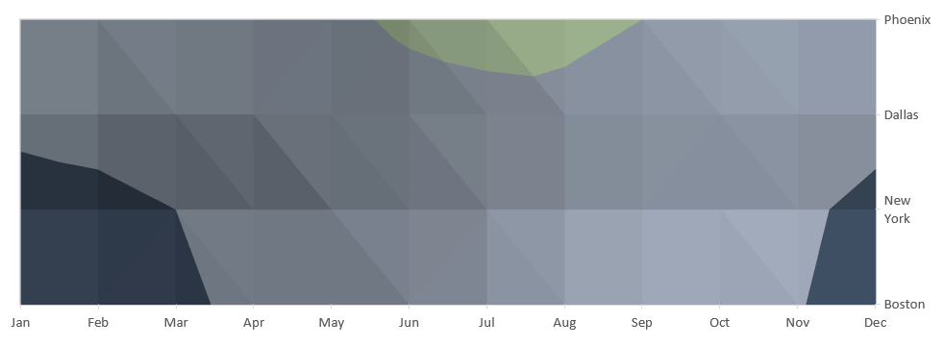

**HOMEWORK: Power Map**

In the **Data_Viz_Homework** file, click on the "Power Map" tab and complete the following:

**1)** Select the accident data in columns A-D, and launch **Power Map**

**2)** Customize the settings to show the sum of Auto Accidents as a **heat map** based on longitude/latitude, with a filter to show locations with **at least** **5** accidents. The resulting map should look like the following:

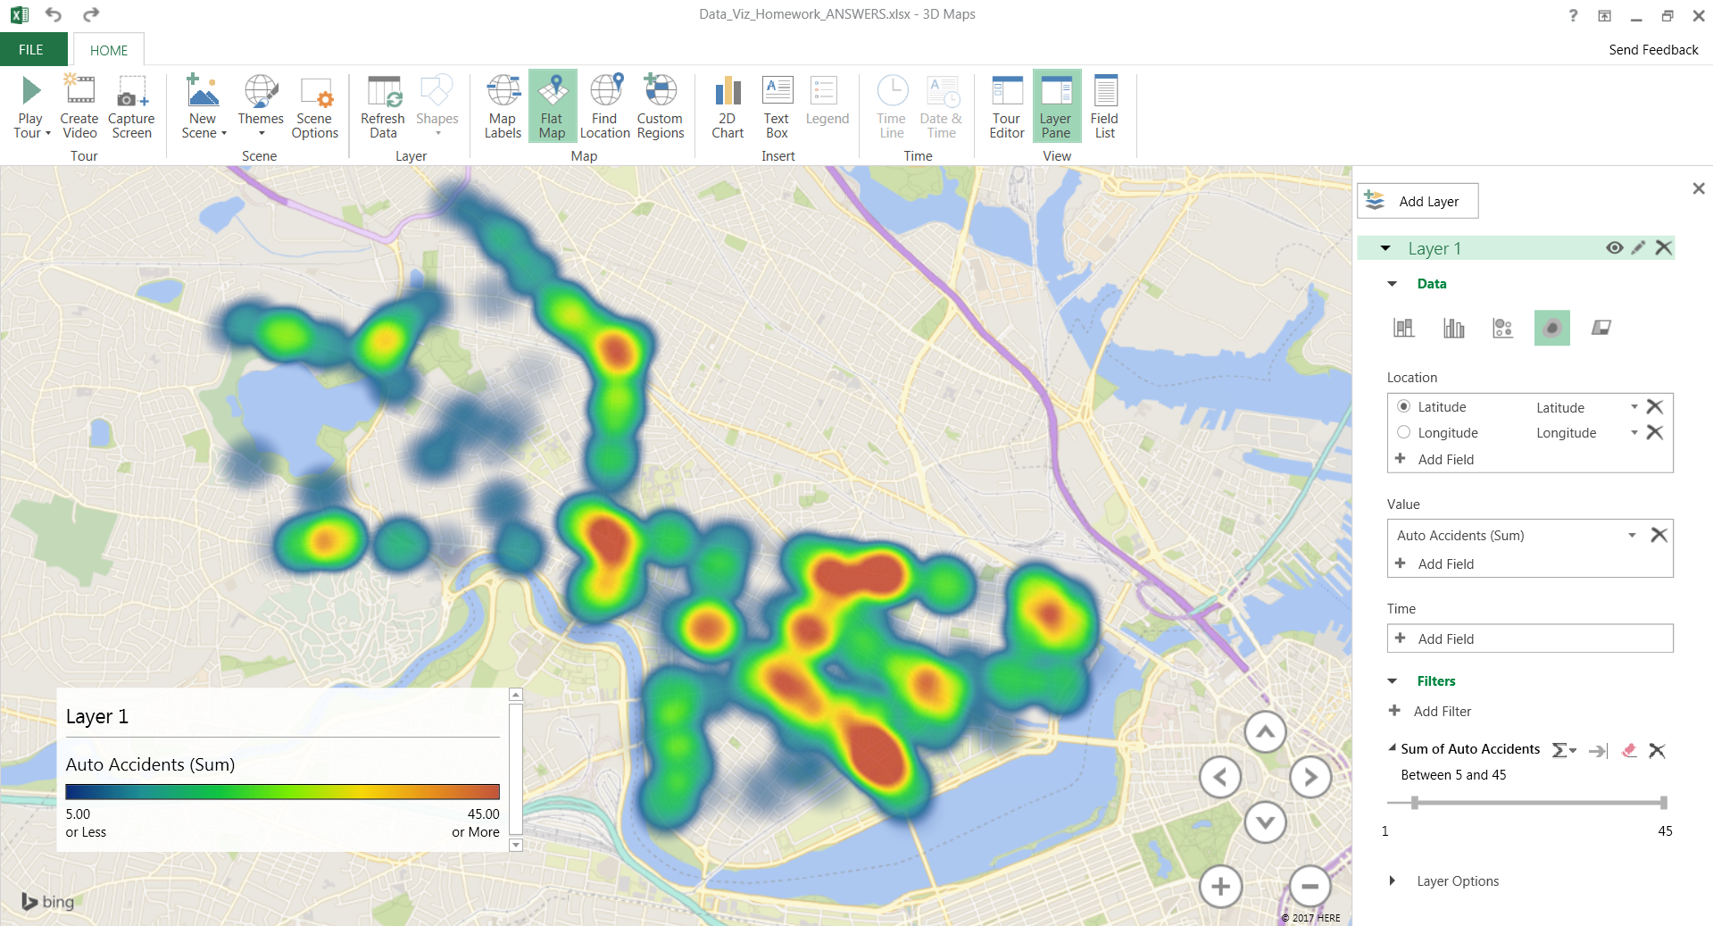

**HOMEWORK: Combo Charts**

In the **Data_Viz_Homework** file, click on the "Combo Charts" tab and complete the following:

**1)** Create a **Combo Chart** showing *Wins* as columns and *Win %* as a line, and adjust formatting to match the example below:

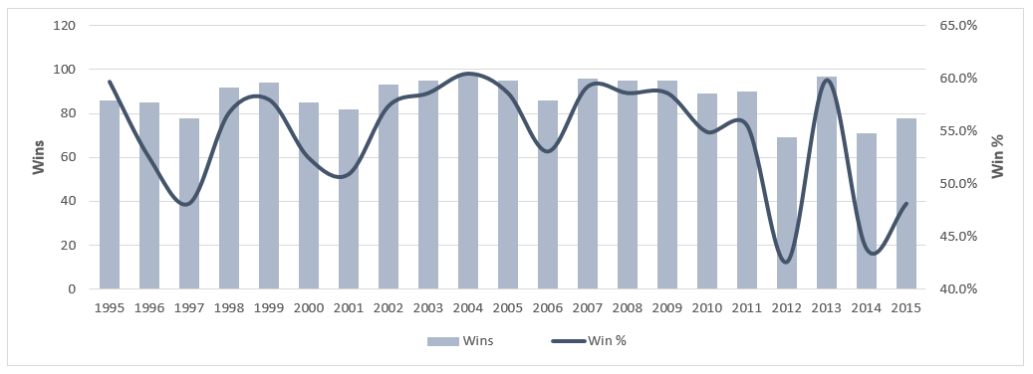

**2)** Create a second **Combo Chart** showing *Runs Scored* as an area and *Batting Avg* as a line, and adjust formatting to match the example below:

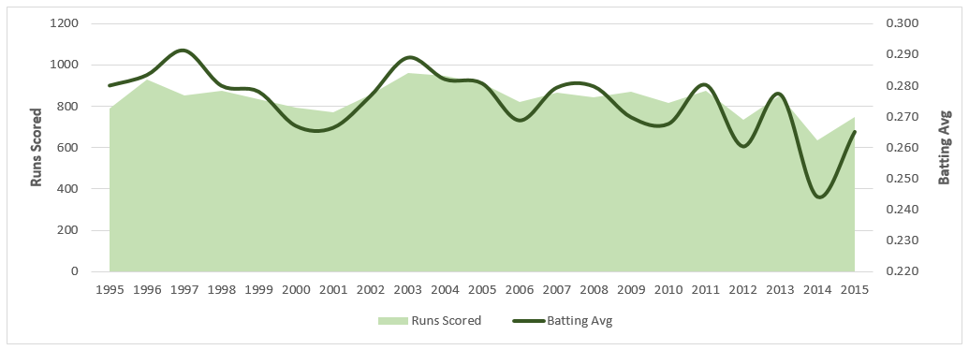

**3)** Create a third **Combo Chart** showing *Runs Scored* and *Runs Allowed* as a **100% Stacked Column** and *ERA* as a line, and adjust formatting to match the example below:

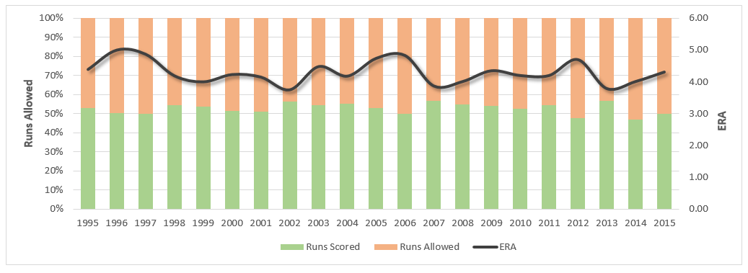

**HOMEWORK: Sparklines**

In the **Data_Viz_Homework** file, click on the "Sparklines" tab and complete the following:

**1)** In column F, insert **Sparklines** as lines to show the accident totals by time of day, with a marker to show the high point

**2)** In row 9, insert **Sparklines** as columns to show the accident totals by day of week, with a marker to show the high point

The resulting sparklines should look like the following example:

